Collection Policy

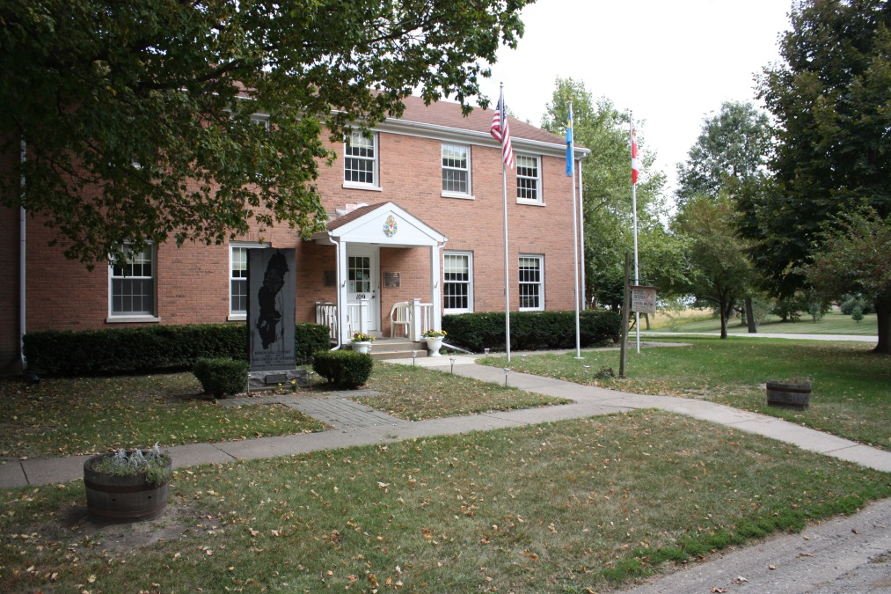

Kathy Cuff, CA
Archivist-Manager
Vasa National Archives

Created August 2016

Contents

Mission Statement, page 3

History, page 3 - 4

Statement of Authority, page 4

Scope of Collection, page 4

Collection Categories, page 5-6

Acquisitions and Accessions, page 6

Deaccessioning and Disposal, page 7

Loans, page 7

Objects in Custody and Abandoned Cultural Property, page 8

Conservation and Care, page 8

Mission Statement

The purpose, as described in the Incorporation Document, is for "Educational, historical and research to preserve, display and make available records, documents, works of art, science, inventions and manufacture by persons of Swedish ancestry and to promote public knowledge of an interest in the history of persons of Scandinavian, particularly Swedish, ancestry."

The main purpose is to preserve the records of the Vasa Order of America and its members. There is a family register where Vasa members and their families are chronicled. The register supports an important phase of the Archive’s mission by assistsing researchers with genealogical explorations. The contents of the archive will remain interesting to all visitors, therefore a number of artifacts related to Swedish and Swedish immigrant history are accepted providing visual and physical connections to past generations.

The Vasa National Archives does not seek collections related to the Eric Jansson or the Janssonist colonists who established Bishop Hill, IL to prevent competition with local Illinois State Historic Sites, Henry County Historical Association and the Bishop Hill Heritage Association. Assistance locating the best repository for such collections will be given to donors of these items.

History

The desire for a central repository for the Vasa Order’s collections began with Bertil Winstrom in the early 1970s. After gaining approval of the Grand Lodge, he began a successful fund raising drive to purchase land and pay for construction. The Archive Committee selected the town of Bishop Hill, IL for the repository due to the centralized location, Swedish heritage and local determination to maintain the historical context of the village. Ground breaking took place on Nov. 23, 1973 and construction continued through the winter. On June 5, 1974, many visitors from the US, Canada and Sweden attended the building dedication. A wide expanse of lawn and huge maple trees surround the building. The building's design complements existing buildings in the village. The Vasa Order added a 20’x 30’ extension to the building in 1995 to accommodate new technology and an ever-growing collection.

Microfilming the records of all Vasa lodges in the U.S. and Canada was an especially valuable and pioneering project carried out by the Vasa Order of America. The project was completed in the 1990s. The archive houses Over 32,000 feet/500 boxes of films. Vasa lodges and other researchers can request viewing the microfilms during normal operating hours.

Vasa members honor departed sisters and brothers, and offer help and sympathies to survivors. The Vasa Order of America National Archives offers many ways to create lasting memorials. Lodges, members, and friends can send a cash memorial to the Archive in memory of a deceased person. Attractive Memorial Cards are located in the Archive in a cabinet donated by Roy Nelson and Bertil Winstrom. These cards forever preserve the memory of a loved one. The person making the donation receives acknowledgement and the family receives a memorial card. Any person or organization may convey a memorial. The person honored need not necessarily be a Vasa member and is referenced when assisting genealogical researchers. Local Lodge Secretaries will be happy to transmit donations to the Archive Financial Secretary. Revenue from the Memorial Cards helps perpetuate the activities of the Vasa National Archives.

Statement of Authority

The Vasa National Archives is a 501 (c) 3 not for profit organization operating under the guidance of a Board of Directors elected by the Vasa Order of America’s Grand Lodge. Board members serve a minimum of four (4) years and can be reelected. Board members begin and end their terms at the Grand Lodge Convention held every four (4) years. The Archivist-Manager directs the daily functions of the archive. Further information about the Board member duties, governance and the Vasa National Archives can be found in the By-Laws for the Vasa National Archives.

Scope of Collection

The Vasa National Archives collects, preserves, and makes available records, genealogical information, events, artworks, publications and other items related to the Vasa Order of America. Vasa Order of America collections aim to document individual members, local lodges, lodge committees, lodge clubs, District Lodges, and the Grand Lodge.

Additional interest in Scandinavian immigration, particularly from Sweden, to the US and Canada encourages collections of materials related to general Scandinavian immigration to North America. These include microfilms of church records, personal correspondence, memoriablia, and other materials.

The Vasa Order of America seeks to help individuals reconnect with their Swedish heritage and ancestors. In accomplishing this task, the Vasa National Archives collects genealogical information from members and other sources.

Collection Categories

The list below is a guideline with exceptions. Donors are encouraged to contact the archive prior to sending donations. The Vasa National Archives tries to keep four (4) copies of any particular item allowing the archive to have use and master copies.

Grand Lodge
​Minutes, reports, by-laws, charters, pictures, convention materials, event flyers or handouts, pins and regalia, correspondence, scholarship winners, award winners, information on old age, death or sick benefits, publications, financial documents, Vasa National Archives and Grand Lodge history.

​

District Lodges

​All of the above plus correspondence, membership information, District Lodge and local lodge pendants/banners, and committees, clubs or organization information within the District Lodge.

​

Local Lodges

​Membership lists, minutes, reports, by-laws, charters, pictures, conventions, information on events, pins and regalia, correspondence, scholarships, awards, information on sick, death or old-age benefits, lodge pendants/banners, history and any special committees within the lodge.

Members
Genealogies, personal histories, crafts/artworks, Vasa regalia and pins, awards/certificates, and other materials.
​

Other items the archive interested in

​Swedish books published in America, genealogical information, materials and information related to Scandinavian (particularly, Swedish) immigration.

Reference Materials
Reference materials related to Scandinavian history and immigration complement the archival materials. Reference materials are collected, organized and made available as a source that enhances understanding of the archival collections but are not considered a part of the archival collections. Reference materials are therefore not subject to the same guidelines, preservation work and accession/deaccession policies as archival collections.

Items the archive is not interested in
The archive recognizes there may be items that have special histories. Donors should contact the archivist for guidance regarding these types of gifts or any of the specific items below.

Bibles, flags, items in very poor or fragile condition, items that pose a threat to people or property, framed items (unless in a specialty frame, very delicate, or an oversized item), financial records unless they are the only source of membership information, and select Vasa publications. Contact the archive for a list of publications needed.

Acquisitions and Accessions

The Vasa National Archive acquires donations through transfer, donation, gift, bequest, and purchase if funds allow. Any acquisitions or accession will be documented in an excel database and a hard copy will be kept in the collection files. All folders will include an itemized list of everything in the collection, appropriate paperwork and correspondence. The archives can assist donors by paying portions or total shipping cost. Payments for shipping will be decided on a case-by-case basis as funds allow. In keeping with professional standards and ethics, items believed to be stolen or have apocryphal provenance (ownership history) cannot be accepted.

Transfer of Records
Materials generated by Vasa Lodges at any level will be considered Transfer of Records. All lodges operate as part of the Grand Lodge, making the records the property of the Vasa Order of America’s Grand Lodge. The records will be transferred from Local or District Historians to the Vasa National Archives as needed and determined by the Local or District Historians. The archivist will be available to assist and consult with Transfer of Records as requested. These transfers will be documented by the archives and an acknowledgement will be sent to the Historian sending the records.

Donations, Gifts, and Bequests
Members and the public are welcome to send materials to the archive as a donation, gift or bequest. Donations, gifts and bequests may come directly from the individual or assigns or through a lodge. All donations, gifts and bequests will be documented and acknowledged. Archive staff will assist with determining restrictions or limitations to the collection’s use. Collections may be received with the understanding that the records, all or portions, will be sealed and inaccessible for a given time period not to exceed 50 years, unless superseded by local, state or federal laws. Any sealed records will be labeled with the date they are available and a very general description of contents, i.e. “personal information”, “memoriabilia”, “medical records”.

Purchase
From time to time, desirable collections may become available via sale. This method of acquisition will be restricted to only collections of significant value to the enhancement of the Vasa National Archive’s Mission and current collections. Purchase of collections will be determined by the Board of Directors with consideration of available funds and any limitations set by the seller(s). Purchases will be given an accession number and receipts, canceled checks, or other documentation will be kept as permanent record of the purchase.

Deaccessioning and Disposal

While the Vasa National Archives strives to collect as many records as possible, it is not possible to keep everything offered to the archives. The Vasa National Archives will prudently and with reservation, determine what collections, or portions of collections, should be deaccessioned and the appropriate method of disposal. The archivist may seek guidance from the Board of Directors with deaccessions and disposal.

Collections may be deaccessioned for the following:
- No longer fits within the mission, purpose, nor enhances existing collections.
- Unable to provide professional care, preservation or maintain the collection.
- Poses a threat to people, other collections, or property.
- Replacement by better representative of the same item, i.e. a signed copy can replace an unsigned copy of the same book.
- Too many existing copies.
- Severe damage preventing use by researchers.

Disposal will be handled with respect to the collection and donor. The archivist will look at the accession records to determine what disposal method the donor preferred and will do due diligence in fulfilling the donor’s wishes. In the event that the donor cannot be located or the donor did not specify a disposal method, the archivist may determine how to dispose of the collection.

Disposal methods:
- Donation to another museum, archive or similar institution.
- Return to donor or heirs.
- Well-advertised public sale with proceeds benefiting the collections at the Vasa National Archives.
- Proper disposal with a local waste management company.

Loans

The Vasa National Archives in a spirit of helping other museums, archives and institutions will allow loans of items to other institutions. All loans will be documented, with renewable termination dates not to exceed one (1) year, and signed by both parties. Unless otherwise stated and approved in writing, the lendee may only lightly dust collection pieces on loan. No photographs, scans or other reproductions will be allowed, of portions or entire piece, unless approved in writing. Incoming and outgoing loans can be documented using Loan Forms from the Vasa National Archives or from the receiving institution. Copies will be housed at both locations. The Vasa National Archives will keep all loan documents, shipping documentation, and correspondence in hardcopy.

Objects in Custody and Abandoned Cultural Property

The Vasa National Archives will not accept donations, gifts, or loans without documentation showing terms and conditions governing the transfer and signed by both parties. The Vasa National Archives conforms to applicable state and federal laws as well as professional ethics and standards.

(765 ILCS 1033/) Museum Disposition of Property Act.
http://www.ilga.gov/legislation/ilcs/ilcs3.asp?ActID=2230&ChapAct=765%26nbsp%3BILCS%26nbsp%3B1033%2F&ChapterID=62&ChapterName=PROPERTY&ActName=Museum+Disposition+of+Property+Act%2E

Items and collections found within the archive with no documentation will be assumed to be donations to or property of the archive. If disposal is necessary of large or valuable items, the Vasa National Archive will conduct a reasonable search for the donor contacting a minimum of four (4) newspapers, The Vasa Star, and two (2) other sources in an attempt to reach the donor. If no donor comes forward within a year, the archive will properly dispose of the item/collection. If the collection or item poses an immediate threat to property or people, it can be immediately neutralized or disposed of prior to seeking the donor and without waiting for a year to pass.

Conservation and Care

In th is section, conservation and preservation may be used interchangeably since they have similar meanings.

To prolong the useful life of collections, the archives will attempt to maintain a temperature of 75° F and humidity of 45% with variance not to exceed 5° or 5% above or below the target. To the best of the archive’s ability, archival products purchased from reputable suppliers will be used to house collections. Researchers will be encouraged to use collections with clean, dry hands or with gloves depending on the collections used.

The archivist will conduct as much preservation as possible within the archives to keep costs low. All preservation, beyond basic cleaning, will be documented in the collection’s file and in keeping with current professional standards. In the event that the archivist cannot conduct the preservation needed, a local preservationist may be sought and hired, with Board approval, to perform the preservation.

